GLOBAL SUPERSTORE ADVANCED CHARTING

AIM:
Create the following chart: Using Global Superstore

- Bar in bar

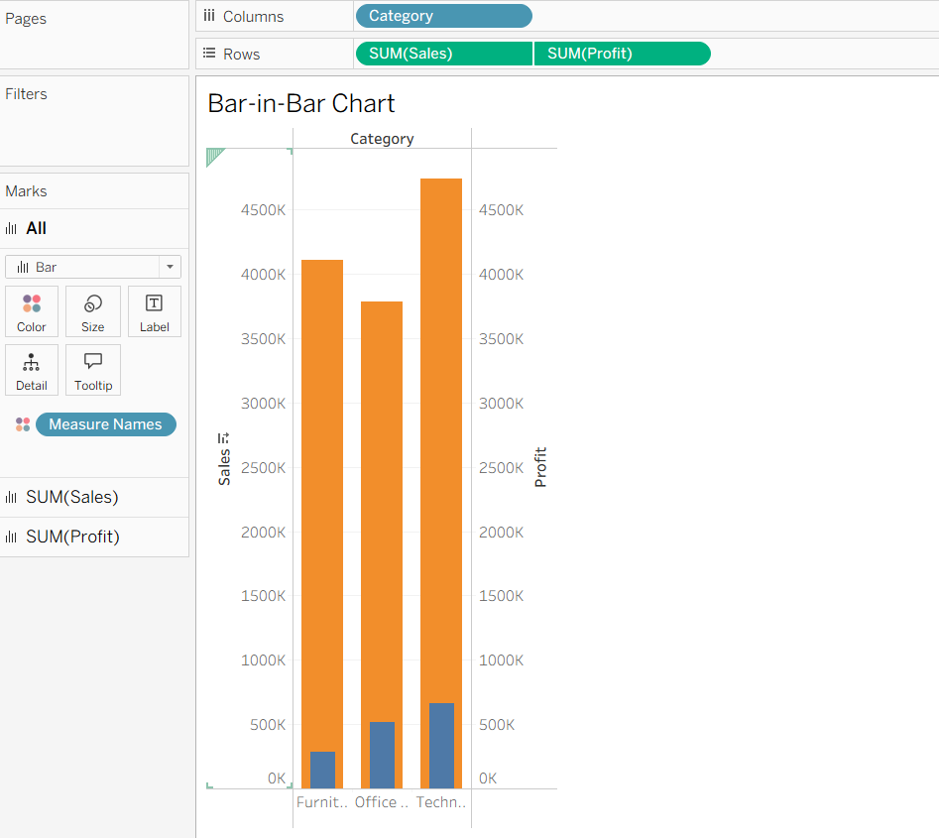

- Bullet

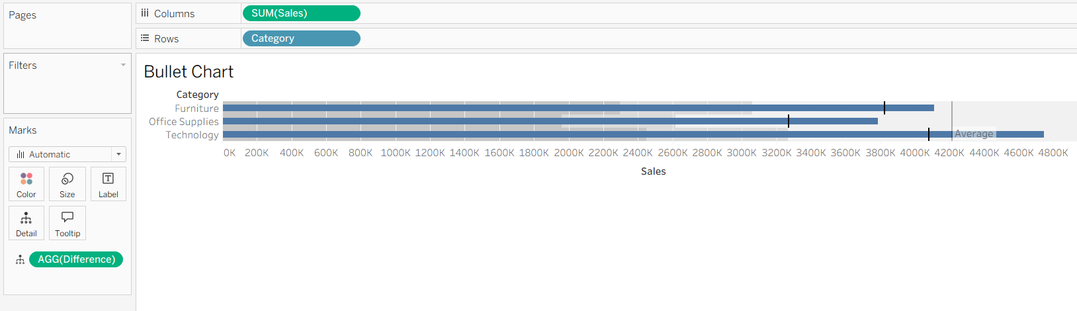

- Barbell

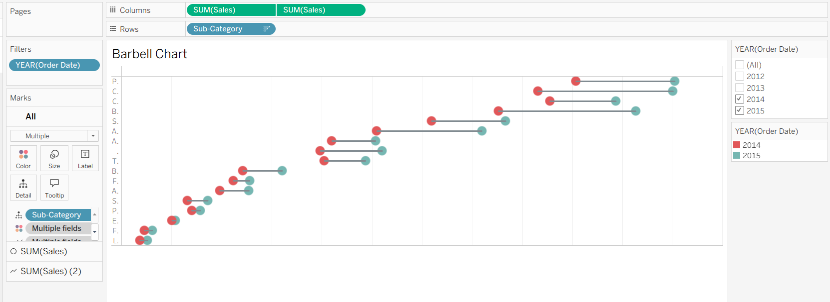

- Lollipop

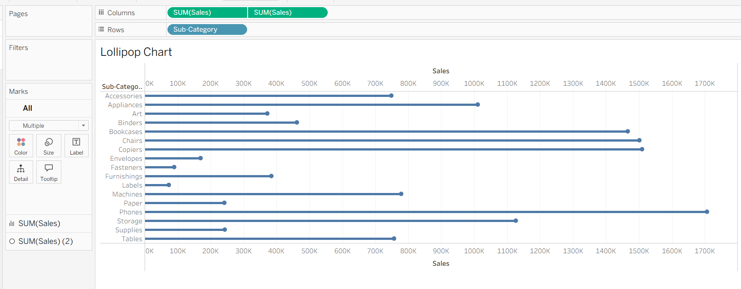

- Bump



